Business Storytelling with Data
Sales Insights, Business Interpretation and Recommendations
PokéMart Sales Dashboard

Dashboard Overview
The dashboard below brings together the main sales KPIs and the available city, category, monthly, product and discount visuals. The five insights in this report are based on what is visible in this dashboard.
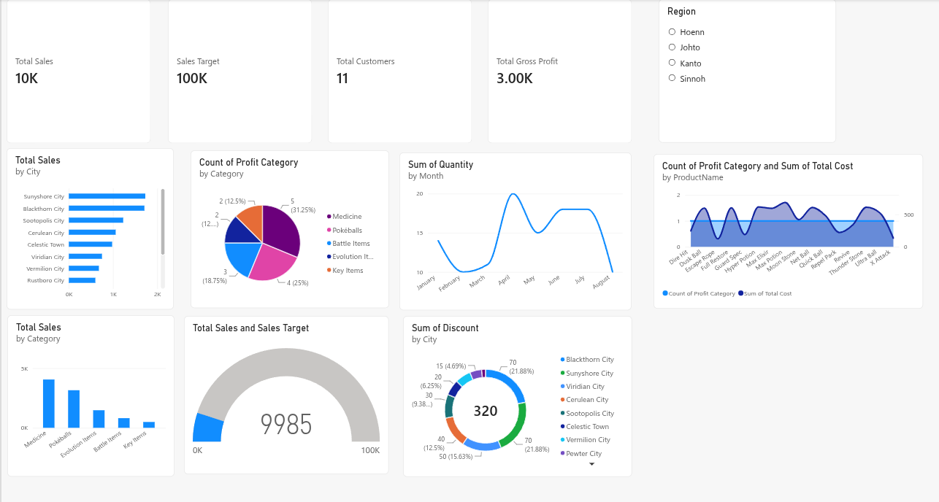

Five Business Insights

1. Sales are well below the defined target
Observation: The Total Sales card shows approximately ₹10K, while the target is ₹100K. The gauge displays 9,985 against a 100K target, which is roughly 10% achievement.
Business interpretation: At the current level, the business is significantly short of its predefined sales goal. The target gap is important because it gives the team a clear measure of how much sales performance needs to improve. The dashboard alone does not explain why the gap exists.
Recommendation: Break the ₹1,00,000 target into weekly or monthly goals. Review sales regularly and track which cities and categories contribute most to closing the gap. Investigate whether the shortfall is related to low order volume, low-value orders or limited demand.

2. Sales contribution differs across product categories
Observation: The category sales column chart shows Medicine as the largest contributor, followed by Pokéballs. Evolution Items contribute less, while Battle Items and Key Items are the smallest contributors in the displayed chart.
Business interpretation: A small number of categories account for a larger share of the visible sales. This means overall revenue is influenced strongly by the performance of the leading categories. The chart shows the difference in sales, but it does not establish the reason for it.
Recommendation: Maintain availability of the leading categories and monitor their sales closely. For lower-contributing categories, test product bundles, promotions or improved placement. Compare results after each change before making it a permanent strategy.

3. Sales vary across cities
Observation: The Total Sales by City bar chart shows different revenue levels across the listed cities. Sunyshore City and Blackthorn City appear among the highest contributors, while several other cities have shorter bars.
Business interpretation: Revenue is not evenly distributed geographically. The stronger cities may offer useful examples of what is working, while lower-contributing cities may need more attention. The chart does not show whether the difference comes from customer count, order size or local demand.
Recommendation: Compare order counts and average order value across cities to understand the difference. Use the stronger cities as a reference, and test locally relevant offers or campaigns in lower-performing cities. Review the results by city rather than applying the same action everywhere.

4. Monthly activity changes over time
Observation: The monthly line chart is labelled Sum of Quantity by Month. Quantity rises to its highest visible point in April, falls in May, increases again around June and July, and drops in August.
Business interpretation: The number of units sold changes from month to month, suggesting that sales activity is not constant throughout the displayed period. This can affect stock planning and campaign timing. Since this visual measures quantity rather than revenue, it should not be described as a monthly revenue trend.
Recommendation: Plan inventory around months with higher observed quantities and review why quantities fall in weaker months. In a future dashboard update, add a monthly Total Sales line chart alongside this quantity trend to distinguish changes in units sold from changes in revenue.

5. Discounts and product costs should be monitored with profitability
Observation: The discount donut shows a total discount value of 320 distributed across cities. The product-level visual compares the count of Profit Category records with Sum of Total Cost. The KPI cards show Total Gross Profit of about 3.00K.
Business interpretation: Discounts reduce the amount collected from sales, while product costs affect the profit remaining after each sale. Looking at these together helps the business avoid focusing on revenue alone. The current visuals do not prove that a particular city or product has poor profitability, so that conclusion would need a clearer profit-by-city or profit-by-category view.
Recommendation: Review discounts alongside sales and gross profit for each city and category. Prioritise promotions that increase sales without reducing profit excessively. Add dedicated Gross Profit by City and Gross Profit by Category charts to make profitability comparisons easier.

Overall Recommendation
The immediate priority should be to close the gap between current sales and the ₹1,00,000 target while protecting gross profit. Focus on the stronger product categories and cities, investigate weaker areas, and use monthly quantity patterns to plan stock and campaigns. A future version of the dashboard should include monthly revenue and profit-by-city/category visuals so that decisions can be based on profitability as well as sales volume.

Note on the Dashboard Data
This report uses the figures and chart labels visible in the supplied dashboard screenshot. Some visuals show quantity, record counts, discounts or costs rather than revenue. The insights therefore describe only what those visuals directly show; causes and trends not present in the dashboard have not been assumed.

